Elmhurst Lions Club

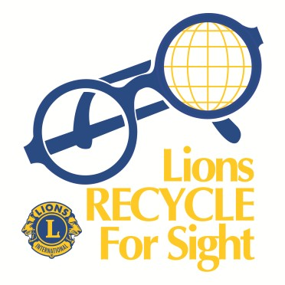

******Eyeglass Recycling******

Eyeglasses can be dropped off at the following locations:

Elmhurst
• Stolper State Farm Insurance Agency, 447 N. York St.
• Ahlgrim Funeral Home, 567 S. Spring
• Skowron Eye Care, 370 N. York St.
• Community Bank of Elmhurst, 330 W. Butterfield Rd.
• Kovach Eye Institute, 152 N. Addison Ave.
• Pedersen-Ryberg Mortuary, 435 N. York St.
• Prairie Path Foot & Ankle Clinic, 136 W. Vallette St., #2
• Elmhurst American Legion, 310 W. Butterfield Rd.
• Edward Jones, Rita Borzym, 188 W. Industrial Dr., Ste. 108
• My Eye Doctor, 138 N. York St.
• Elmhurst Public Library, 125 S. Prospect Ave.

Since 1994 the Lions of Illinois Foundation have sent more than
5,500,000 pair of used eyeglasses around the world.

HELP SUPPORT THE ELMHURST LIONS CLUB SERVING THE VISION AND HEARING NEEDS OF OUR COMMUNITY
www.elmhurstlions.org

